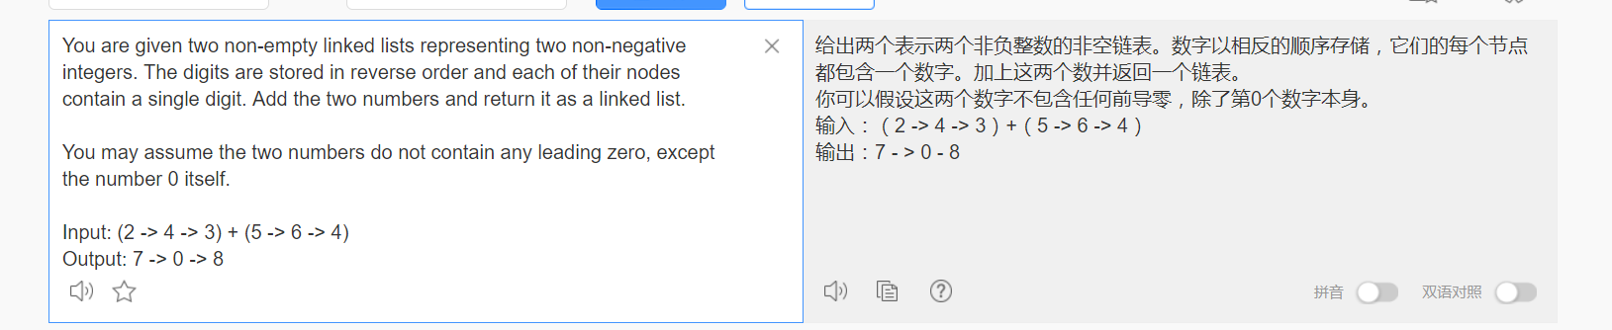
原题如上，
思路:
按照其顺序挨个计算，如果计算结果>10，那么就在下一位的时候初始化为1.
我的答案:

class Solution {
public:
ListNode* addTwoNumbers(ListNode* l1, ListNode* l2) {
ListNode *p = l1;
ListNode *q = l2;
ListNode *res = NULL;
ListNode *Tback = NULL;
int f = 0;
while (1) {
int num = f;
if (p != NULL)
num += p->val;
if (q != NULL)
num += q->val;
res = new ListNode(num % 10);
f = num / 10;
res->next = Tback;
Tback = res;
res = NULL;
if (p != NULL)
p = p->next;
if (q != NULL)
q = q->next;
if(p==NULL && q==NULL && f==0)return resver(Tback);
}
return Tback;

}
ListNode* resver(ListNode *l) {
ListNode *p = l;
ListNode *q = NULL;
int len = 0;
while (p != NULL) {
len++;
p = p->next;
}
if (len == 0)
return q;
p = l;
int res[len];
int index = len - 1;
while (p != NULL) {
res[index--] = p->val;
p = p->next;
}
ListNode* qq = NULL;
for (int i = len - 1; i >= 0; i--) {
q = new ListNode(res[i]);
q->next = qq;
qq = q;
q = NULL;
}
return qq;
}
};

结果:

英语的重要性！！！刚开始还以为是只有第二个是颠倒的！

